* Router to router – WAN connection – Serial connection
* Need serial cables
* Two 2911 routers
* Use DTE/DCE cable
* Take DCE cable

Follow the steps

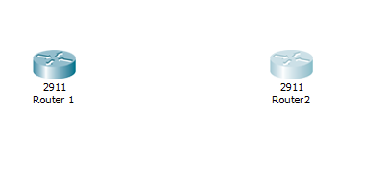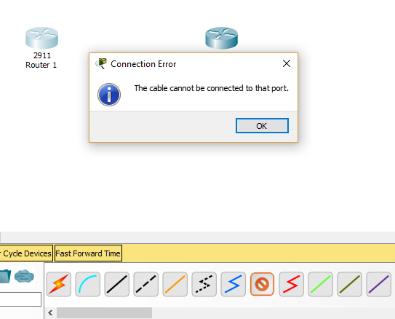

* Issue: cable cannot be connected to that port
* We need to add **serial interface** in order to connect **serial cable**
* Double click on router

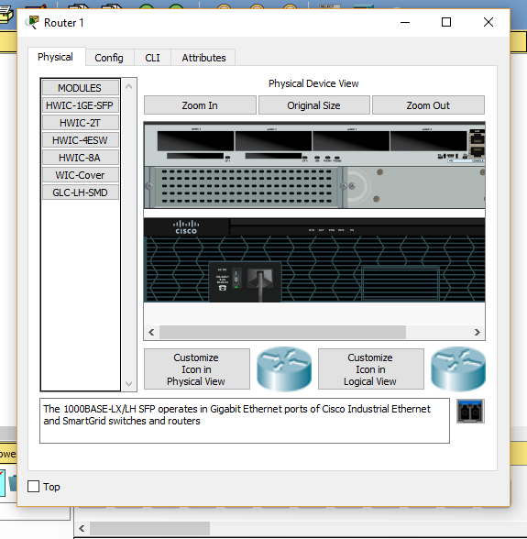

* From modules, select HWIC – 2T

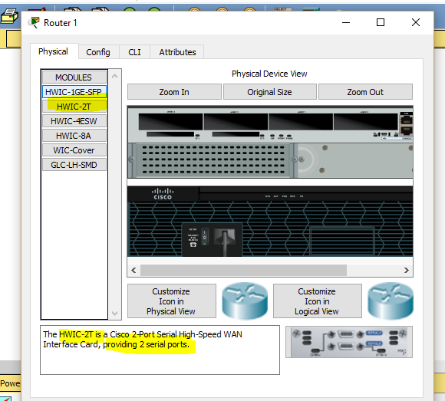

* Drag and drop, HWIC – 2T interface

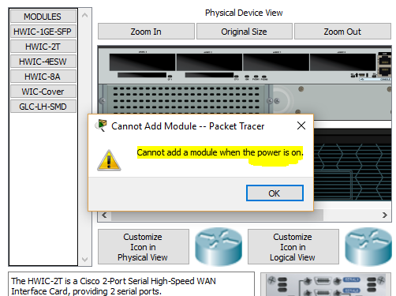

* Issue : Power is on
* Switch off the router
* Drag and drop, HWIC – 2T interface
* Switch ON the router

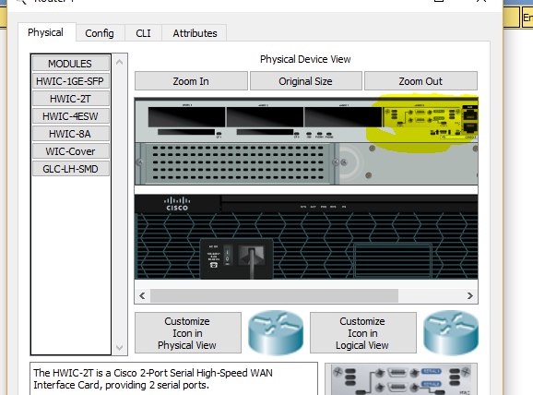

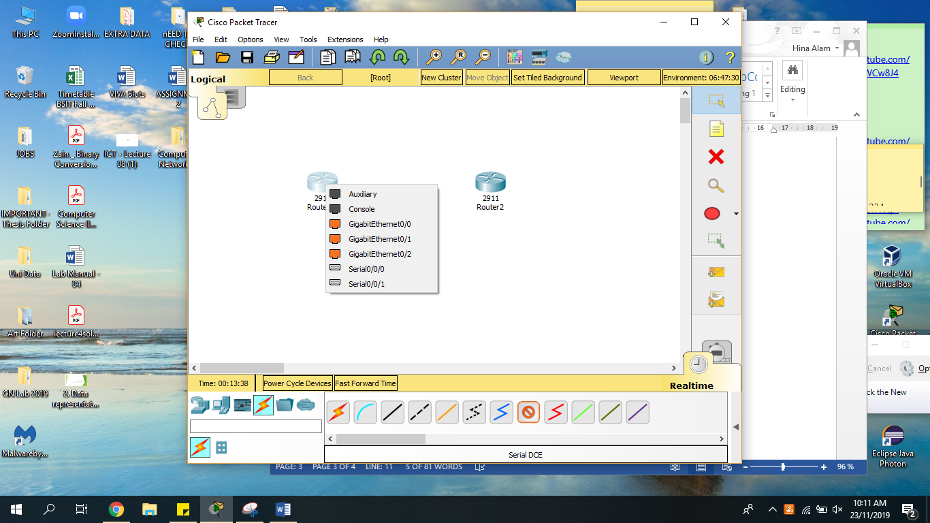

**SAME STEPS FOR ALL ROUTERS**